

**UNIVERSITY OF SCIENCE AND TECHNOLOGY OF HANOI**

**REPORT**

**Wikipedia Client**

GROUP 10

Subject: Mobile Application Development

**TABLE OF CONTENTS**

**MEMBERS**

**I. INTRODUCTION**

1. Overview
2. Purpose
3. Wikipedia Mobile App

**II. METHODS**

1. UI Structure
2. Use Case Diagram
3. XML Design
4. Libraries

**III. RESULT**

**IV. CONCLUSION**

**MEMBERS**

Lê Phước Long BI9-153

Đặng Hùng Kiên BI9-133

Nguyễn Quý Minh BI10-089

Phạm Trung Kiên BI10-089

Nguyễn Hoàng Minh BI10-112

1. **INTRODUCTION**

**1, Overview**

* Wikipedia is a free content, multilingual online encyclopedia written and maintained by a community of volunteers through a model of open collaboration, using a wiki-based editing system.
* Wikipedia was launched on January 15, 2001, by [Jimmy Wales](https://en.wikipedia.org/wiki/Jimmy_Wales) and [Larry Sanger](https://en.wikipedia.org/wiki/Larry_Sanger)
* The name as a [blending](https://en.wikipedia.org/wiki/Portmanteau) of "wiki" and "encyclopedia"
* In 2021, Wikipedia was ranked the 13th most popular site by Alexa.

**2, Purpose**

* Wikipedia is great place to start your research, giving you background information on your topic and possible keywords to help you conduct more in-depth research elsewhere.
* Wikipedia is completely free, constantly updated by the hour.

**3, Wikipedia Mobile App**

* Open knowledge that’s always ad-free and never tracks your data.
* Articles on Wikipedia are freely licensed and the app code is 100% open source.
* 40 million articles in over 300 languages.
* Offline Mode - Save your favorite articles
* Night Reading - Night mode

1. **METHODS**
2. **UI Structure**

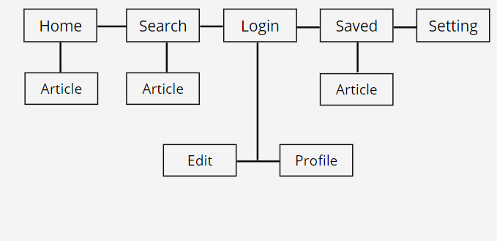

1. **Usecase Diagram**

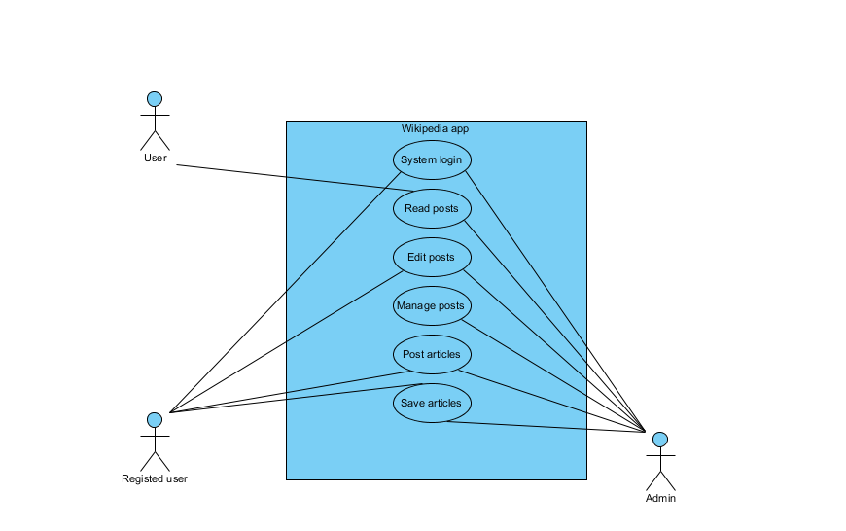

1. **XML Design**

* **Activity main - Activity page**

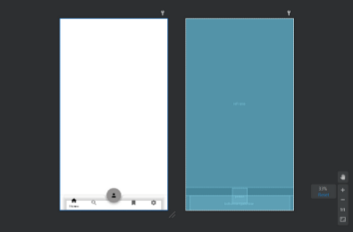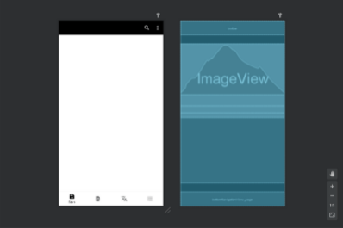

* **Fragment home - Fragment save**

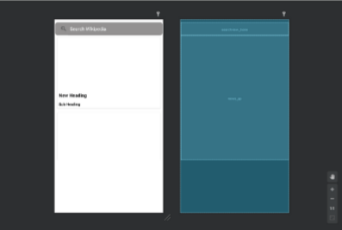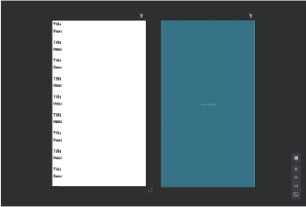

* **Fragment setting - Preference**

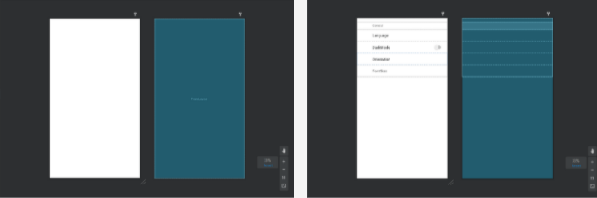

* **Fragment search**

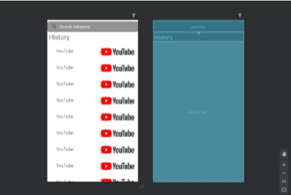

1. **Libraries**

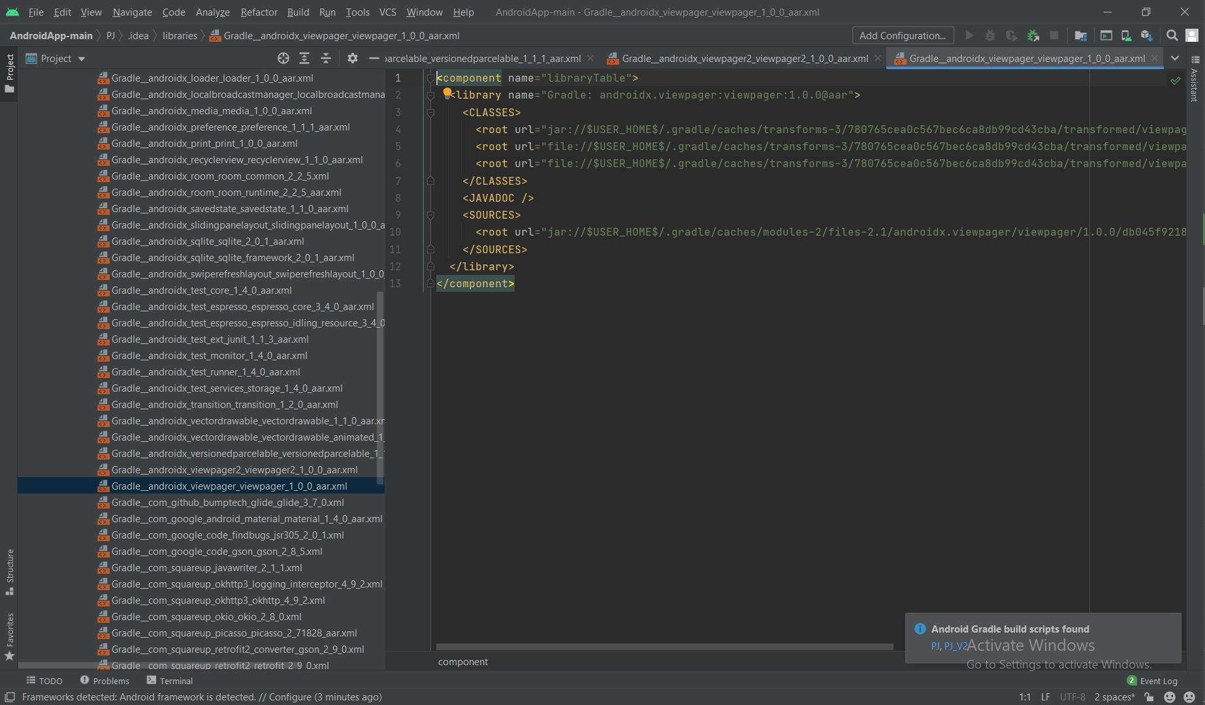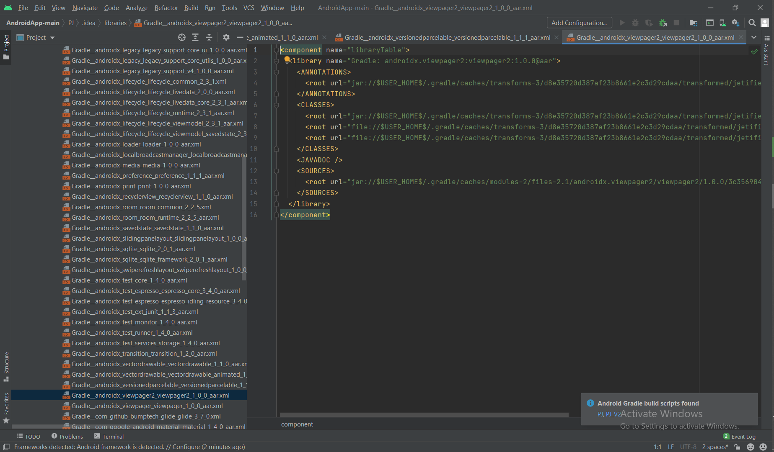

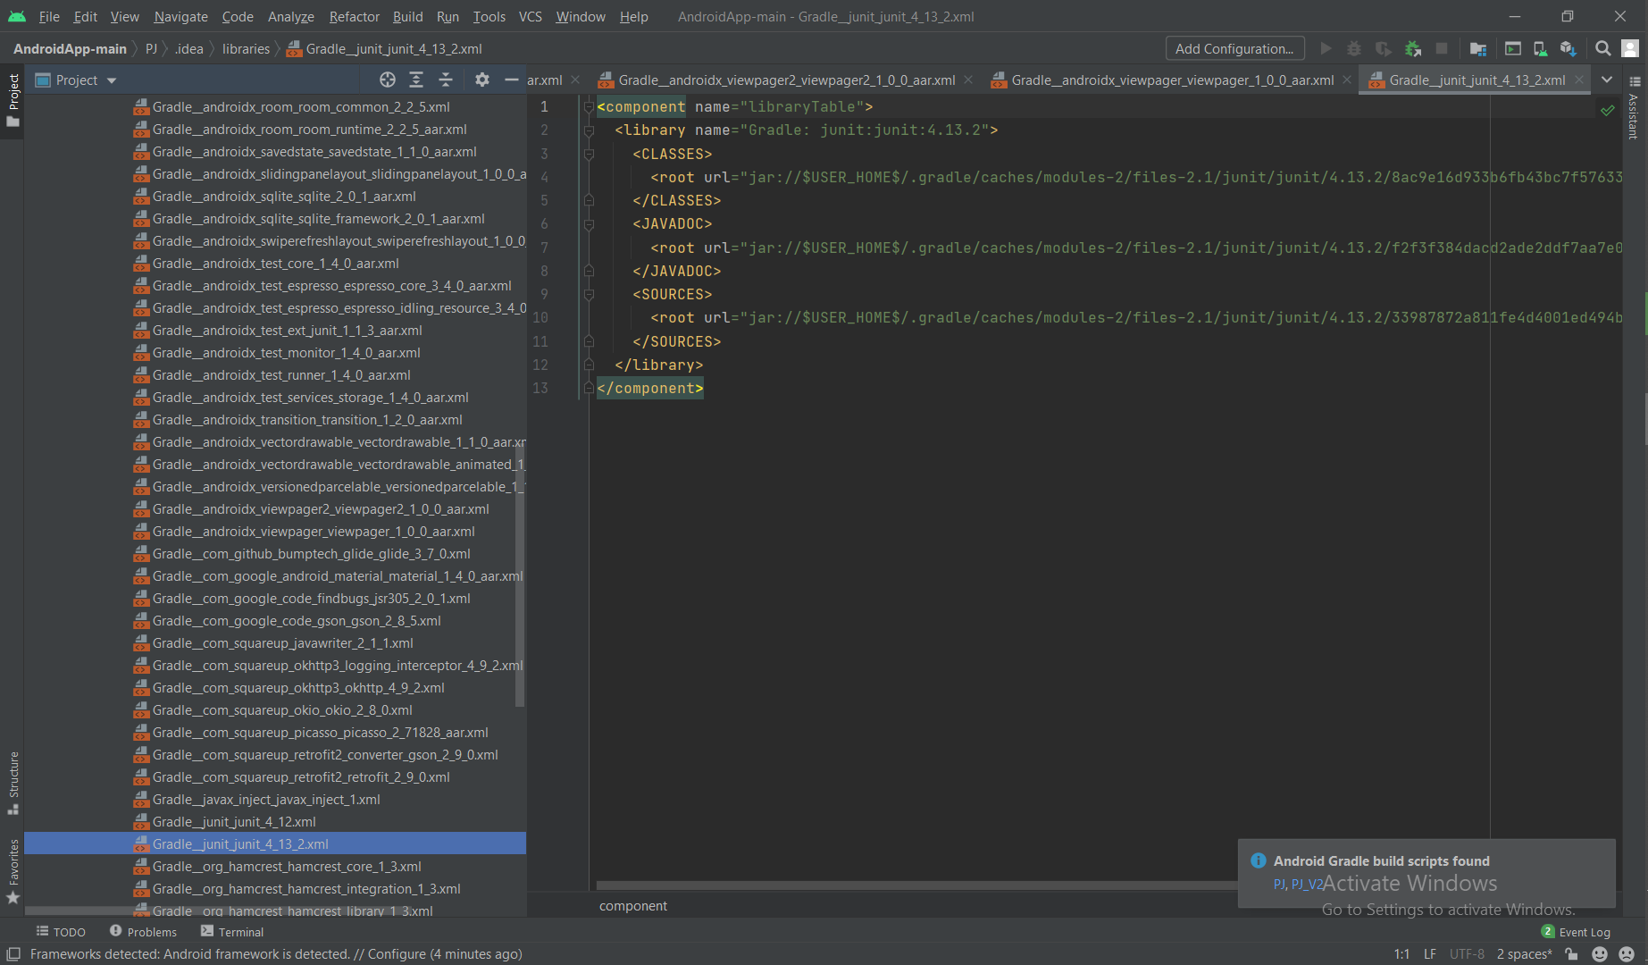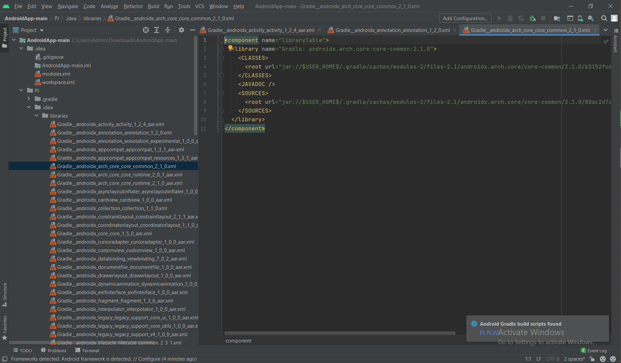

1. **RESULTS**

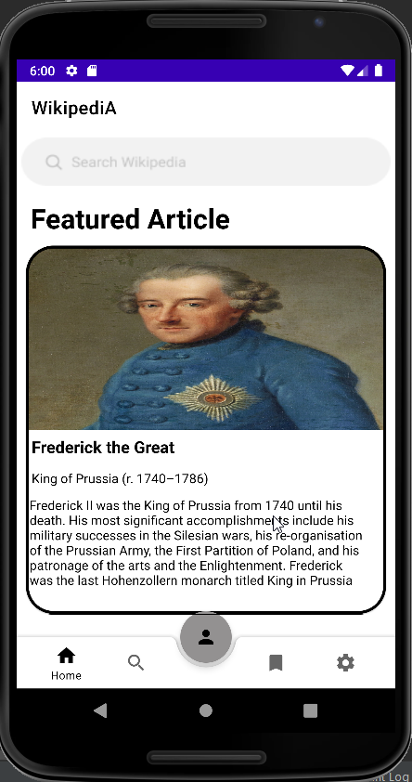**Homepage**

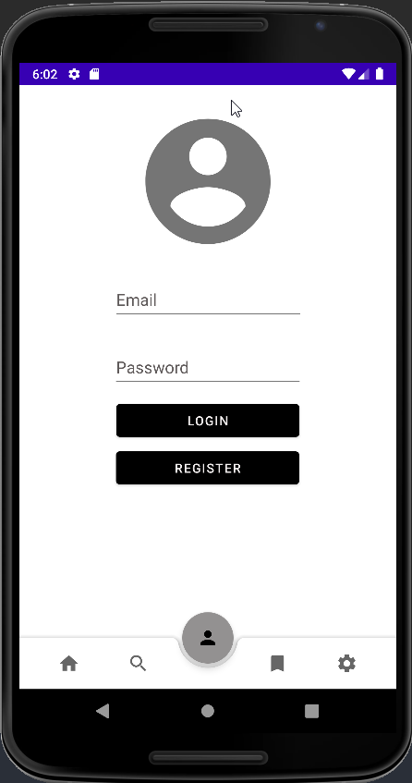

**Login page**

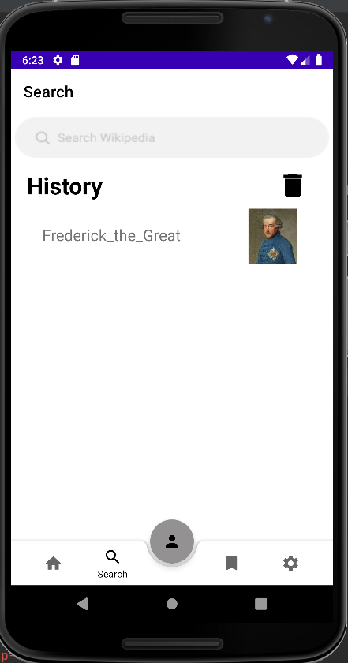

**Search page**

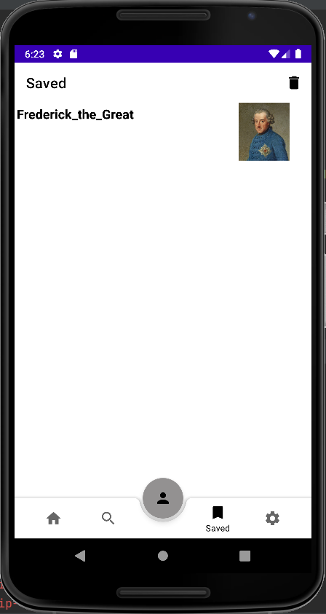

**Saved page**

1. **CONCLUSION**

* **Update the previous version of the wiki app:**
* Read new article
* Search article
* Have some setting element
* **Not finish these functions:**
* Save article following created list
* Log in as users
* Edits, change, add new images for an article
* **Link of our codes:** <https://github.com/hm1905/AndroidApp?fbclid=IwAR26YujRozM7yenDvLvVzQBsAlHMhRIs2NeKdp8RHVST3Klb28LSPj0vf2U>